**Social media websites exploratory analysis and prediction**

**Akanksha Koatgiri1, Egna2, Charan3, Dheraz4, Kuruva Sriman Narayana5**

1,2,3,4,5School of Computer Science and Engineering, VIT-AP University, Amaravati, Andhra Pradesh, India

**ABSTRACT**

The exponential growth of social media platforms has transformed how individuals communicate, interact, and share information. In this research paper, we conduct an exploratory analysis and prediction of user behavior on social media websites. We employ open-vocabulary exploratory analysis to systematically understand the underlying patterns in social media data, which include sentiments, health indicators, and personality traits. Additionally, we explore the challenges of identifying and selecting relevant features that can aid in the proactive detection of malicious entities such as hackers. By leveraging machine learning algorithms and a vast dataset mined from social media platforms, we demonstrate the potential of predictive models to forecast outcomes with significant accuracy. Our findings suggest that while social media can be a powerful tool for prediction, it also poses challenges related to data quality and model generalizability. This research contributes to the field by providing insights into the effective use of social media data for predictive purposes and by highlighting the importance of careful feature selection in the development of robust predictive models. This includes various machine learning algorithms such as linear regression, logistic regression, Naive Bayes, decision tree, and K-nearest neighbors (KNN) to analyze patterns, predict user engagement, and explore factors influencing user interactions. Through comprehensive data analysis and modeling, we provide insights into user behavior on social media platforms and offer predictive models to enhance understanding and inform decision-making processes for platform optimization.

**Keywords:** Social media, prediction, analysis, Exploration, Algorithms and Modellings

1. **INTRODUCTION**

Exploratory analysis is a critical first step in data analysis, where the main goal is to understand the underlying structure and characteristics of the data. It involves summarizing the main characteristics, often with visual methods, to uncover patterns, spot anomalies, test hypotheses, or check assumptions. Exploratory analysis and prediction enable social media platforms and businesses to make data-driven decisions, enhance user experience, and stay ahead in the competitive digital landscape.

Exploratory Analysis: Data Visualization**:** Graphical representations such as histograms, box plots, scatter plots, and heatmaps to see trends and outliers.

Summary Statistics: Measures like mean, median, mode, variance, and standard deviation to describe data distribution.

Correlation Analysis: Identifying relationships between variables to understand how they may affect each other.

Prediction:

Predictive Modeling: Using statistical techniques to make forecasts about future events based on current and historical data.

Machine Learning: Applying algorithms that can learn from and make predictions on data, such as regression, classification, and clustering.

The process of exploratory analysis and prediction is iterative and often requires refining the approach based on findings. It is widely used in various fields, including finance, marketing, healthcare, and social media analytics, to inform decision-making and strategy development.

Tools like natural language processing, text mining, and machine learning are integral to these processes, allowing for large-scale analysis and prediction in real-time.

Marketing: Companies use EDA to understand customer sentiment and preferences, which helps in tailoring marketing strategies to target audiences more effectively.

1. **METHODS**
2. **Exploratory Analysis:**

Exploratory Data Analysis (EDA) is a powerful tool for enhancing social media websites. By scrutinizing user interactions, content trends, and engagement metrics, EDA uncovers valuable insights. It enables platforms to:

A. Optimize Content Strategy: EDA reveals which types of posts (text, images, videos) resonate most with users. Platforms can tailor content accordingly.

B. Identify Influencers: By analyzing follower counts, likes, and comments, EDA identifies influential users. Platforms can collaborate with them for wider reach.

C. Detect Anomalies: EDA helps spot unusual patterns (e.g., sudden spikes in engagement) that may indicate bot activity or viral content.

D. Enhance User Experience: Insights from EDA inform interface design, personalized recommendations, and ad targeting. In summary, EDA empowers social media platforms to adapt, engage, and thrive.

**1.1 Data Visualization**

Data visualization is a powerful ally in the realm of exploratory data analysis (EDA) for social media websites. By transforming raw data into visual representations, it unveils hidden patterns, correlations, and insights. Through charts, graphs, and interactive plots, we gain an intuitive understanding of user interactions, content trends, and engagement metrics. Visualizing likes, shares, comments, and impressions allows us to refine digital strategies.

1. Understanding User Interactions:
   * Social media metrics, such as likes, shares, comments, and impressions, are essential for comprehending user behavior.
   * Visualizations allow us to grasp the distribution of these metrics, identify outliers, and understand their impact.
2. Synthetic Dataset Example:
   * Imagine a synthetic dataset mimicking real-world engagement metrics. Here are some key features:
     + User\_ID: A unique identifier for each user.
     + Followers\_Count: The number of followers.
     + Post\_Type: Categorical feature representing post types (Text, Image, Video).
     + Post\_Length: Length of posts in characters.
     + Post\_Frequency: How often a user posts.
     + Likes\_Received, Comments\_Received, and Share\_Count: Metrics reflecting user engagement.Benefits of Data Visualization in EDA:
   * Intuition: Visualizations provide an intuitive understanding of data distributions, skewness, and central tendencies.
   * Pattern Recognition: Graphs and charts reveal patterns, clusters, and anomalies.
   * Correlation Exploration: Scatter plots, heatmaps, and correlation matrices help identify relationships between variables.

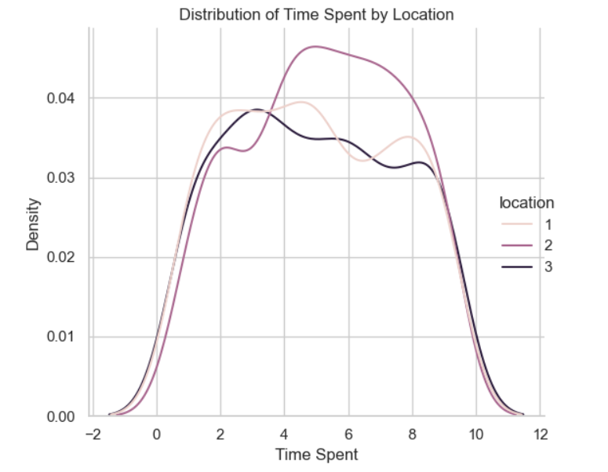

**Figure 1**: A line graph Representation of Density of Time spent on social media in different locations (1- United Kingdom, 2- Australia, 3- United States)

**1.2 Summary Statistics**

## Summary statistics act as a compass for exploratory analysis of social media data, revealing key features briefly. By calculating measures like average post length, follower count distribution (mean, median), and frequency of mentions (hashtags, keywords), we can grasp user engagement patterns, content trends, and potential outliers for further investigation. This initial quantitative understanding paves the way for deeper dives into specific aspects of the social media landscape.

* Central Tendency: Measures like mean, median, and mode tell us about the "typical" value within a dataset. expand\_more They help us understand what kind of content (post length, comment count, etc.) is most prevalent on the platform. Deviations from the mean can indicate outliers or potential areas of interest (e.g., unusually long posts with high engagement).
* Distribution: Measures like variance and standard deviation show how spread out the data is.expand\_more A high standard deviation for post length suggests a diverse range of content formats (short snippets vs. long articles) being shared.exclamation Conversely, a low standard deviation might indicate a more uniform content style.
* Measures of Association: Correlation coefficients assess the strength and direction of relationships.

Benefits of Summary Statistics in EDA:

* Identifying Patterns: They quickly reveal central tendencies, outliers, and potential relationships within the data.expand\_more This can guide further exploration into specific user segments, content types.
* Data Cleaning: Identifying outliers through measures like standard deviation can highlight potential data quality issues that require cleaning before further analysis.

**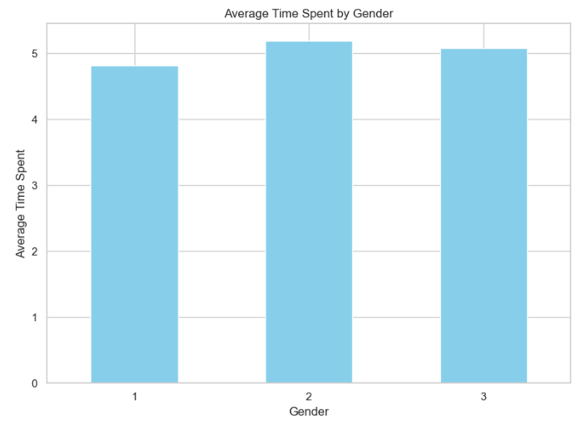**

**Figure 2:** A Bar graph Representation of Time spent by different gender groups in the social media (1- Male, 2- Female, 3- Non-Binary)

**2. Prediction basis:**

Prediction analysis plays a pivotal role in enhancing social media websites. By leveraging algorithms and statistical models, it enables platforms to anticipate user behavior and optimize their strategies. Here’s how prediction analysis benefits social media:

**Content Personalization:**

* 1. Predictive models analyze historical and real-time data to recommend personalized content to users.
  2. By understanding individual preferences, platforms can serve relevant posts, ads, and product recommendations.

**Engagement Forecasting:**

* 1. Predictive analytics helps estimate future engagement metrics (likes, shares, comments).
  2. Platforms can allocate resources effectively, prioritize high-impact content, and enhance user interactions2.

**Trend Prediction:**

* 1. Predictive models identify emerging trends, hashtags, and viral topics.
  2. Platforms can proactively engage with trending content and adapt their strategies3.

**User Churn Prevention:**

* 1. Predictive algorithms detect signs of user disengagement or churn.
  2. Platforms can intervene by offering personalized incentives or improving user experience1.

**2.1 Predictive Modeling**

Predictive modeling acts as a crystal ball for social media analysis, sifting through mountains of user data (posts, likes, shares) to identify patterns and trends. These patterns are then used to train algorithms that can anticipate future behaviors like viral trends, customer sentiment, and even potential brand crises, allowing social media platforms to stay ahead of the curve.

1. Data Acquisition and Cleaning:

* The first step involves collecting relevant data from the social media platform. This could include user demographics, post content, engagement metrics (likes, shares, comments), and even sentiment analysis of the text.
* Data cleaning is crucial to ensure the model's accuracy. Inconsistent formats, missing values, and irrelevant information need to be addressed before feeding the data into the model.

2. Feature Engineering:

* Raw social media data might not be directly usable by the model. Feature engineering involves transforming the data into a format suitable for the chosen modeling technique. This might involve creating new features based on existing ones, like sentiment score based on post text.

3. Model Selection and Training:

* Different predictive modeling techniques exist, each with its strengths and weaknesses.
* The chosen model is trained using a portion of the cleaned data. The model learns to identify patterns and relationships between input features (e.g., post content) and desired outputs (e.g., user engagement).

4. Prediction and Analysis:

* Once a well-performing model is established, it can be used to predict future outcomes on new, unseen data. This allows social media platforms and businesses to:
  + Identify potential influencers: By analyzing user behavior and engagement, models can predict which users are most likely to influence others' opinions and actions.
  + Manage customer service: Sentiment analysis through predictive modeling can help identify potentially dissatisfied users, enabling proactive customer service interventions.
  + Forecast trends and events: Analyzing social media conversations can help predict upcoming trends and events, allowing businesses to adapt their strategies accordingly.

**2.2 Machine Learning**

Machine learning acts as a powerful tool for social media prediction analysis by sifting through massive amounts of user data. These algorithms can analyze text, images, and even user interaction patterns to uncover hidden trends and relationships. Machine learning can also predict user behavior, allowing platforms to recommend content or target advertising with higher accuracy. This not only improves user experience but also helps businesses refine their social media strategies.

Data Processing Powerhouse:

* Massive Data Handling: Social media generates enormous amounts of data – posts, comments, shares, etc. Machine learning algorithms can efficiently process this data to identify patterns and trends that humans might miss.

Understanding User Behavior:

* Predicting User Actions: By analyzing past behavior (likes, shares, comments), machine learning can predict what kind of content a user is likely to engage with in the future. This allows social media platforms to personalize user feed’s and recommendations.
* Sentiment Analysis: Machine learning can analyze the tone of text in posts and comments to understand user sentiment – positive, negative, or neutral. This helps brands gauge customer satisfaction and identify potential issues.

Content Optimization and Targeting:

* Viral Content Prediction: Machine learning models can analyze the characteristics of posts that go viral and predict which new content has the potential to gain traction. This helps creators and marketers optimize their content strategies.
* Targeted Advertising: Social media platforms use machine learning to target ads to specific user demographics and interests. This improves ad effectiveness and ROI for businesses.

**2.2.1 Linear Regression**

Linear regression, while a powerful tool, has limitations in social media prediction analysis due to the complex nature of user behavior.

* Linear Relationships: Linear regression assumes a straight-line relationship between variables. Social media interactions are often non-linear, with factors like virality and network effects playing a bigger role.
* Limited Features: It works best with a few independent variables. Capturing the nuances of social media with just a few factors might not be enough for accurate predictions.

However, linear regression can still be useful in specific scenarios:

* Simple Correlations: It can identify basic correlations, like how ad spend might influence follower growth (assuming a somewhat linear increase).
* Baseline Model: It can serve as a baseline model for comparison with more complex algorithms like decision trees or neural networks.

**2.2.2 Logistics Regression**

Logistic regression is a powerful tool for binary classification tasks in social media prediction analysis.

Here is how it shines:

* Strengths:
  + Interpretability: Unlike complex models, logistic regression provides clear insights into which factors (e.g., number of followers, post frequency) influence the predicted outcome. This allows social media platforms to understand why certain content performs better.
  + Efficiency: It's computationally efficient, making it ideal for analyzing large datasets generated by social media platforms.
  + Clear Probabilities: It predicts the probability of an event happening (e.g., a post going viral) which helps prioritize content strategies.
* Applications:
  + User Engagement: Predicting the likelihood of a user engaging with a post (like, comment, share) based on its content and user characteristics.
  + Content Performance: Estimating the probability of a post going viral or reaching a wider audience.
  + Ad Targeting: Identifying users most likely to click on an ad based on their social media activity.

**2.2.3 Naive Bayes**

Naive Bayes is a powerful tool for prediction analysis in social media, particularly when dealing with text data. Here is how it shines:

* Strength in Text Classification: Naive Bayes excels at classifying text into different categories. This makes it ideal for sentiment analysis on social media, where it can analyze posts.
* Fast and Efficient: Compared to some complex algorithms, Naive Bayes is computationally efficient, making it suitable for handling the massive datasets generated by social media platforms.
* Handling Large Vocabularies: Social media text is full of slang, emojis, and informal language. Naive Bayes can handle these variations effectively by using on word probabilities within a specific context.

**2.2.4 Decision Tree**

Decision trees are like workhorse algorithms for prediction tasks on social media. Here is how they shine in this domain:

* User Action Prediction: Imagine a decision tree for predicting post engagement. It might start by asking: "Is the post a video?" If yes, it might branch to "Is the video length under 2 minutes?". Each branch further refines the prediction based on user data (past watch time for videos) and post characteristics. This helps social media platforms tailor content and predict which posts will get the most likes or shares.
* User Segmentation: Decision trees can also segment users into groups based on their activity. The tree might ask questions like "Does the user follow mostly humor accounts?" or "Does the user frequently share news articles?". These segments help platforms personalize content recommendations and targeted advertising.
* Interpretability: Unlike some complex algorithms, decision trees are easy to visualize and understand. This allows social media analysts to see the logic behind the predictions and identify which factors have the strongest influence on user behavior.

**2.2.5 KNN**

K-Nearest Neighbors (KNN) can be a useful tool for some prediction tasks on social media websites,

But it has its strengths and weaknesses:

* Simple and interpretable: KNN is easy to understand and implement. It works by finding the closest data points (based on chosen features) to a new data point and predicting the class (or value) based on most of its neighbors.
* Effective for certain tasks: KNN can be useful for tasks where data points cluster well and clear boundaries exist between classes. For example, it might be helpful in classifying content sentiment (positive, negative) if past data shows distinct patterns in language use.

1. **RESULTS AND DISCUSSION**

Overall, this project underscores the transformative potential of machine learning in leveraging social media data for actionable insights, paving the way for innovative solutions to complex societal challenges and enhancing decision-making processes across various sectors.

The performance of each model is evaluated using appropriate evaluation metrics such as accuracy. By leveraging machine learning techniques to analyze social media data, stakeholders can tailor targeted interventions, financial products, and educational campaigns to address the diverse needs of different user segments. Moreover, the methodology outlined in this project serves as a valuable blueprint for future research endeavors aimed at leveraging social media data for predictive analytics in diverse domains, including finance, marketing, and public policy.

1. **CONCLUSION**

In conclusion, our research of exploratory analysis and prediction within the context of social media analytics, a domain crucial for understanding user behavior, optimizing content strategies, and informing decision-making processes.

Through the utilization of various analytical techniques and tools, we gained valuable insights into user interactions, trends, and predictive modeling on social media platforms.

Exploratory analysis provided us with a lens to visualize and interpret the underlying patterns and outliers in our data. Through graphical representations such as histograms, box plots, scatter plots, and heatmaps, we identified trends, outliers, and correlations among variables, shedding light on factors influencing user engagement and content performance.

Summary statistics served as quantitative measures to describe the central tendency, dispersion, and shape of our data distribution. Metrics such as mean, median, mode, variance, and standard deviation provided valuable insights into the variability and distribution of user engagement metrics, guiding our understanding of user behavior on social media platforms.

Prediction, facilitated through predictive modeling and machine learning algorithms, enabled us to forecast future events and trends based on historical and current data. Regression, classification, and clustering techniques empowered us to make informed predictions about user behavior, content performance, and emerging trends, driving actionable insights and decision-making.

The iterative nature of exploratory analysis and prediction necessitates continual refinement and adaptation of approaches based on findings.

**Future Scope:**

As technology continues to evolve and social media platforms undergo rapid changes, the scope for exploratory analysis and prediction in social media analytics is poised for further expansion. Several avenues offer promising opportunities for future research and real-world applications:

1. Advanced Predictive Modeling: Future research could focus on enhancing predictive modeling techniques by integrating advanced machine learning algorithms, such as deep learning and ensemble methods. These approaches can capture intricate patterns and nonlinear relationships in social media data, leading to more accurate predictions of user behavior and content performance.
2. Real-Time Analysis: With the increasing demand for real-time insights, there is a need to develop robust frameworks and algorithms for conducting exploratory analysis and prediction in real-time.
3. Cross-Platform Analysis: As users engage with multiple social media platforms simultaneously, there is a need for cross-platform analysis to understand user behavior across different platforms.
4. Predictive Analytics for Crisis Management: Social media platforms can serve as valuable sources of information during crises and emergencies.
5. **REFERENCES**
6. **Conference:** Lalitha Minocha, Praveen Jain, Amit Singh, Pradeep Pandey “Social Media’s Impact on Business and Society: A Study.” 2022 Conference Paper, IEEE.
7. **Conference:** Zhu Aihua, Chen Xi “A revie of Social Media and Social Business” 2012 Conference Paper, IEEE.
8. **Conference:** [Hamda Al-Boinin](https://ieeexplore.ieee.org/author/37089198041" \t "_self), [Wajdi Zaghouani](https://ieeexplore.ieee.org/author/38580693500" \t "_self), [Savanid Nui Vatanasakdakul](https://ieeexplore.ieee.org/author/37659260000" \t "_self) “[Women Micro-Entrepreneurs in Qatar: Motivation, Challenges, and Social Media Opportunities](https://ieeexplore.ieee.org/document/9635560/)” 2021 Conference Paper, IEEE.
9. **Conference:** [Fabio Persia](https://ieeexplore.ieee.org/author/37589394700" \t "_self), [Mouzhi Ge](https://ieeexplore.ieee.org/author/37086363684" \t "_self), [Daniela D'Auria](https://ieeexplore.ieee.org/author/37085355761" \t "_self) “How to Exploit Recommender Systems in Social Media” 2018 Conference Paper, IEEE.
10. **Conference:** [Israa Bukhari](https://ieeexplore.ieee.org/author/38558620400" \t "_self), [Cliff Wojtalewicz](https://ieeexplore.ieee.org/author/38557483500" \t "_self), [M. Vorvoreanu](https://ieeexplore.ieee.org/author/38489915200" \t "_self), [J. Eric Dietz](https://ieeexplore.ieee.org/author/38556665200" \t "_self) “ Social media use for large event management: The application of social media analytic tools for the Super Bowl XLV”

2012 Conference Paper, IEEE.

1. **Conference:** [Yuehan Chen](https://ieeexplore.ieee.org/author/37089321128" \t "_self), [Atichart Harncharnchai](https://ieeexplore.ieee.org/author/37086463440" \t "_self), [Teeraporn Saeheaw](https://ieeexplore.ieee.org/author/37086124306" \t "_self) “ Social Media Marketing Strategy Framework of SMEs Using Customer Knowledge Management” 2022 Conference Paper, IEEE.

### **Conference:** [Edi Irawan](https://ieeexplore.ieee.org/author/37088461746" \t "_self), [Teddy Mantoro](https://ieeexplore.ieee.org/author/37422958300" \t "_self), Media [Anugerah Ayu](https://ieeexplore.ieee.org/author/38294549100" \t "_self), [M. Agni Catur Bhakti](https://ieeexplore.ieee.org/author/37086779296" \t "_self), [I Komang Yogi Trisna Permana](https://ieeexplore.ieee.org/author/37089696218" \t "_self) “[Analyzing Reactions on Political Issues in Social Media Using Hierarchical and K-Means Clustering Methods](https://ieeexplore.ieee.org/document/9415839/)” 2020 Conference Paper, IEEE.

### **Conference:** [Mesut Çiçek](https://ieeexplore.ieee.org/author/37086707880" \t "_self), [Selami Özcan](https://ieeexplore.ieee.org/author/37086707670" \t "_self) “[Examining the demographic features of Turkish Social Media users and their attitudes towards social media tools](https://ieeexplore.ieee.org/document/6689597/)” 2013 Conference Paper, IEEE.

1. **Conference:** N. Raja “Concurrent Social Media in Collaborative Media Education 2023, Conference Paper, IEEE.

### **Conference:** [Lei Han](https://ieeexplore.ieee.org/author/37088947319" \t "_self), [Yi Shen](https://ieeexplore.ieee.org/author/37088946794" \t "_self) “[Design of Social Media User Satisfaction Evaluation System from the Perspective of Big Data Services](https://ieeexplore.ieee.org/document/9516581/)” 2021, Conference Paper, IEEE.

### **Conference:** [Zhaoxia Wang](https://ieeexplore.ieee.org/author/38184055800" \t "_self), [Chee Seng Chong](https://ieeexplore.ieee.org/author/37086049761" \t "_self), [Landy Lan](https://ieeexplore.ieee.org/author/37086058630" \t "_self), [Yinping Yang](https://ieeexplore.ieee.org/author/37086629493" \t "_self), [Seng Beng Ho](https://ieeexplore.ieee.org/author/37088102435" \t "_self), [Joo Chuan Tong](https://ieeexplore.ieee.org/author/37085495186" \t "_self) “[Fine-grained sentiment analysis of Social Media with emotion sensing](https://ieeexplore.ieee.org/document/7821783/)” 2016, Conference Paper, IEEE.

### **Conference:** [Emad Farouq Al-Amarnih](https://ieeexplore.ieee.org/author/624806669920373" \t "_self), [Ziyad Kamel Ellala](https://ieeexplore.ieee.org/author/37089927295" \t "_self), [Khawlah M. AL-Tkhayneh](https://ieeexplore.ieee.org/author/37089670316" \t "_self), [Eman Saleh Almasri](https://ieeexplore.ieee.org/author/579688224385568" \t "_self) “The Impact of Using Social Media Platforms (X) as an Example on Shaping Linguistic Awareness” 2023, Conference Paper, IEEE.

### **Conference:** [Dimitrios Amanatidis](https://ieeexplore.ieee.org/author/38017809700" \t "_self), [Ifigeneia Mylona](https://ieeexplore.ieee.org/author/37087097159" \t "_self), [Michael Dossis](https://ieeexplore.ieee.org/author/37547922700" \t "_self) “Social Media [and Consumer Behaviour: Exploratory Factor Analysis](https://ieeexplore.ieee.org/document/9932979/)” 2022, Conference Paper, IEEE.

### **Conference:** [Nelly Sergidou](https://ieeexplore.ieee.org/author/37090015694" \t "_self), [Vasiliki Trigka](https://ieeexplore.ieee.org/author/37090010738" \t "_self), [Nicolas Tsapatsoulis](https://ieeexplore.ieee.org/author/37271573200" \t "_self) “Social [vs News Media in Politics: Revisiting the Case of the 2015 Greek Bailout Referendum](https://ieeexplore.ieee.org/document/10255164/)” 2023, Conference Paper, IEEE.

### **Conference:** [Marc A. Smith](https://ieeexplore.ieee.org/author/37654306800" \t "_self) “NodeXL: Simple network analysis for Social Media” 2013, Conference Paper, IEEE.